Sumama Rahim
F24BSCS039
Database systems Lab 07 Task Report

Name | Sumama Rahim | Course | Database Systems (CSC-103) | Dprtt/ Program | IET - BSCS
Registration | F24BSCS039 | Instructor | Dr. M. Bilal Shahnawaz | Date | 05/04/2025

Lab 07 Task Report

Response:
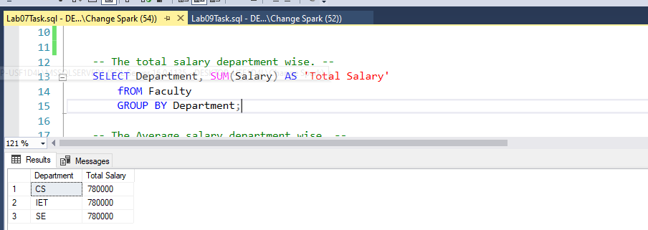

Response:
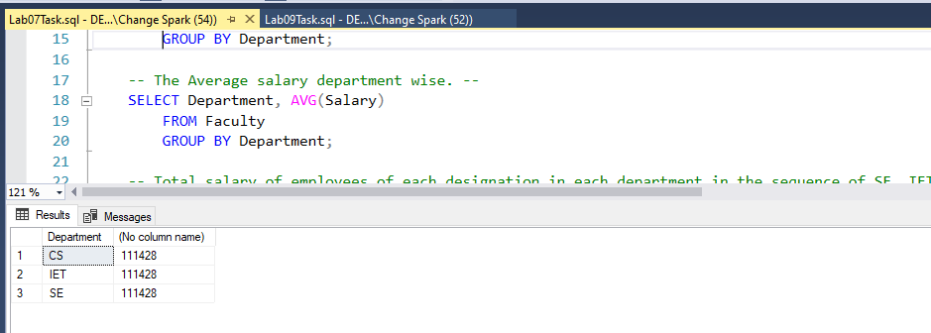

Response:
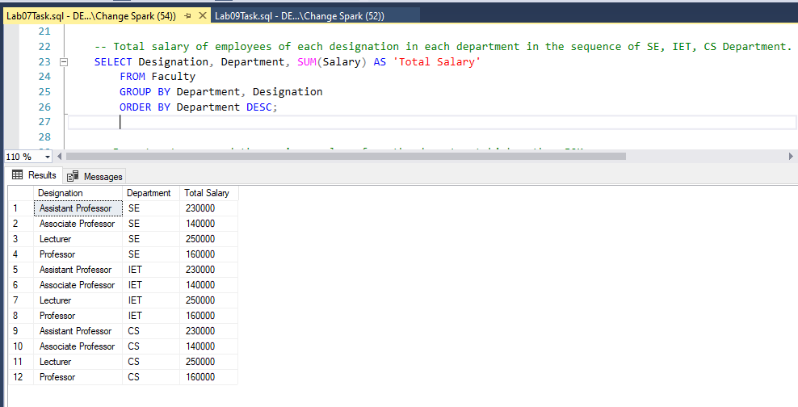

Response:
